

**MOBILE APPLICATION DEVELOPMENT**

**LAB TERMINAL**

**NAME:**

**MUHAMMAD MUAAZ SHOAIB**

**REG. NO:**

**FA20-BCS-074**

**CLASS:**

**BCS-6B**

**SUBMITTED TO:**

**MR. BABAR SHAHZAD**

**DATE:**

**15-JUNE-2023**

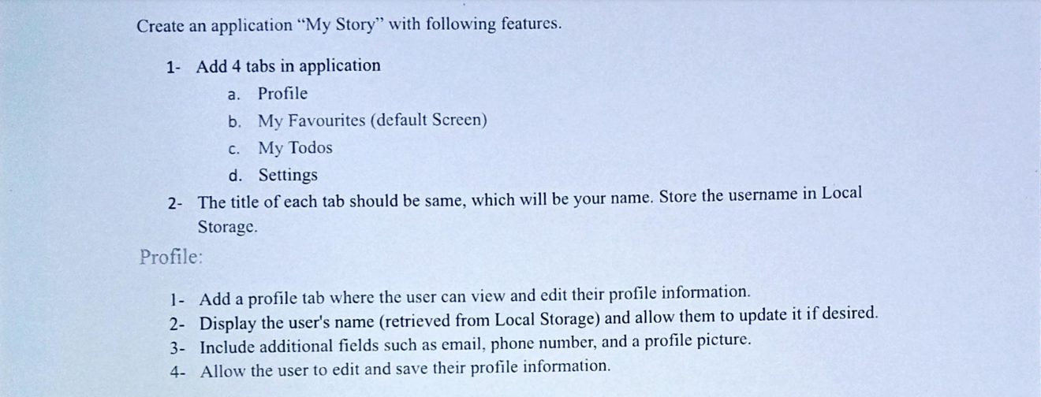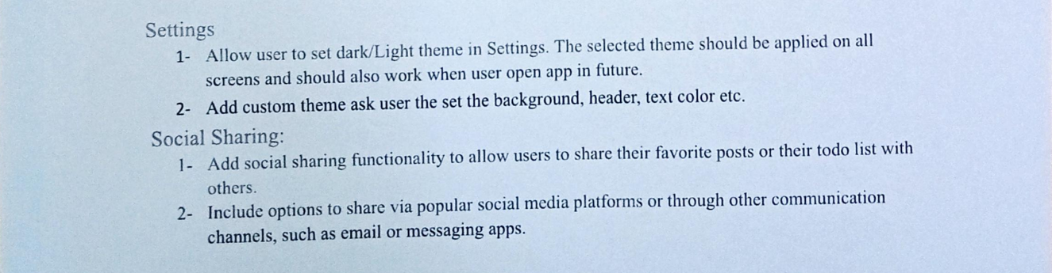

**SCREENSHOTS OF APP**

**APP.JS**

import * as React from "react";

import { useState, useEffect, useContext } from "react";

import AsyncStorage from "@react-native-async-storage/async-storage";

import { NavigationContainer } from "@react-navigation/native";

import { EventRegister } from "react-native-event-listeners";

import TabNavigation from "./navigation/TabNavigation";

import { createNativeStackNavigator } from "@react-navigation/native-stack";

import themeContext from "./config/themeContext";

import theme from "./config/theme";

const Stack = createNativeStackNavigator();

export default function App() {

  const [mode, setMode] = useState(false);

  const [title, setTitle] = useState("");

  useEffect(() => {

    const fetchStackTitle = async () => {

      try {

        var userInformation = await AsyncStorage.getItem("@storage_Key");

        userInformation = JSON.parse(userInformation);

        setTitle(userInformation["name"]);

      } catch (error) {

        console.log("Error retrieving stack title:", error);

      }

    };

    fetchStackTitle();

  }, []);

  useEffect(() => {

    let eventListener = EventRegister.addEventListener(

      "changeTheme",

      (data) => {

        setMode(data);

        console.log(data);

      }

    );

    return () => {

      EventRegister.removeEventListener(eventListener);

    };

  });

  return (

    <themeContext.Provider value={mode === true ? theme.dark : theme.light}>

      <NavigationContainer>

        <Stack.Navigator

          screenOptions={{

            // headerShown: false,

            title: title,

          }}

        >

          <Stack.Screen

            name="TabNavigation"

            component={TabNavigation}

          ></Stack.Screen>

        </Stack.Navigator>

      </NavigationContainer>

    </themeContext.Provider>

  );

}

**TABNAVIGATION.JS**

import * as React from "react";

import { createBottomTabNavigator } from "@react-navigation/bottom-tabs";

import SignIn from "../pages/SignIn";

import Profile from "../pages/Profile";

import Favorites from "../pages/Favorites";

import Todo from "../pages/Todo";

import Settings from "../pages/Settings";

import { Ionicons } from "@expo/vector-icons";

export default function TabNavigation() {

  const Tab = createBottomTabNavigator();

  return (

    <Tab.Navigator

      screenOptions={({ route }) => ({

        tabBarIcon: ({ focused, color, size }) => {

          let iconName;

          <ion-icon name="log-in-outline"></ion-icon>;

          if (route.name === "SignIn") {

            iconName = focused ? "log-in" : "log-in-outline";

          } else if (route.name === "Profile") {

            iconName = focused ? "person" : "person-outline";

          } else if (route.name === "Favorites") {

            iconName = focused ? "heart" : "heart-outline";

          } else if (route.name === "Todo") {

            iconName = focused

              ? "checkmark-circle"

              : "checkmark-circle-outline";

          } else if (route.name === "Settings") {

            iconName = focused ? "settings" : "settings-outline";

          }

          return <Ionicons name={iconName} size={size} color={color} />;

        },

        tabBarActiveTintColor: "blue",

        tabBarInactiveTintColor: "gray",

        headerShown: false,

        tabBarShowLabel: false,

      })}

    >

      <Tab.Screen name="SignIn" component={SignIn} />

      <Tab.Screen name="Profile" component={Profile} />

      <Tab.Screen name="Favorites" component={Favorites} />

      <Tab.Screen name="Todo" component={Todo} />

      <Tab.Screen name="Settings" component={Settings} />

    </Tab.Navigator>

  );

}

**THEME.JS**

const theme = {

  light: {

    theme: "light",

    color: "black",

    background: "white",

  },

  dark: {

    theme: "dark",

    color: "white",

    background: "black",

  },

};

export default theme;

**THEMECONTEXT.JS**

import React, { createContext } from "react";

const themeContext = createContext({});

export default themeContext;

**SIGNIN.JS**

import * as React from "react";

import {

  Text,

  View,

  StyleSheet,

  TouchableOpacity,

  TextInput,

} from "react-native";

import { useState } from "react";

import { createNativeStackNavigator } from "@react-navigation/native-stack";

import { Feather } from "@expo/vector-icons";

import AsyncStorage from "@react-native-async-storage/async-storage";

import themeContext from "../config/themeContext";

import { useContext } from "react";

const Stack = createNativeStackNavigator();

const Page = ({ navigation, route }) => {

  const theme = useContext(themeContext);

  const [email, setEmail] = useState(null);

  const [name, setName] = useState(null);

  const [password, setPassword] = useState(null);

  const [phoneNumber, setPhoneNumber] = useState(null);

  return (

    <View style={[styles.container, { backgroundColor: theme.background }]}>

      <Text style={[styles.title, { color: theme.color }]}>Sign In</Text>

      <View style={styles.inputContainer}>

        <Feather name="user" size={24} color="#999" />

        <TextInput

          style={styles.input}

          placeholder="Name"

          placeholderTextColor="#999"

          value={name}

          onChangeText={(text) => setName(text)}

        />

      </View>

      <View style={styles.inputContainer}>

        <Feather name="mail" size={24} color="#999" />

        <TextInput

          style={styles.input}

          placeholder="Email"

          placeholderTextColor="#999"

          value={email}

          onChangeText={(text) => setEmail(text)}

        />

      </View>

      <View style={styles.inputContainer}>

        <Feather name="lock" size={24} color="#999" />

        <TextInput

          style={styles.input}

          placeholder="Password"

          placeholderTextColor="#999"

          secureTextEntry

          value={password}

          onChangeText={(text) => setPassword(text)}

        />

      </View>

      <View style={styles.inputContainer}>

        <Feather name="phone" size={24} color="#999" />

        <TextInput

          style={styles.input}

          placeholder="Phone"

          placeholderTextColor="#999"

          value={phoneNumber}

          onChangeText={(text) => setPhoneNumber(text)}

        />

      </View>

      <TouchableOpacity

        style={styles.button}

        onPress={async () => {

          if (

            name == null ||

            email == null ||

            password == null ||

            phoneNumber == null

          ) {

            alert("Please fill out all fields.");

            return;

          }

          try {

            const userInformation = {

              name: name,

              email: email,

              password: password,

              phoneNumber: phoneNumber,

            };

            await AsyncStorage.setItem(

              "@storage_Key",

              JSON.stringify(userInformation)

            );

            console.log("Data is saved!");

            console.log(userInformation);

            alert("Data is saved!");

          } catch (e) {}

        }}

      >

        <Text style={styles.buttonText}>SAVE DATA</Text>

      </TouchableOpacity>

      <TouchableOpacity

        style={styles.button}

        onPress={async () => {

          try {

            var userInformation = await AsyncStorage.getItem("@storage_Key");

            userInformation = JSON.parse(userInformation);

            navigation.navigate("Profile", {

              Name: userInformation["name"],

              Email: userInformation["email"],

              Password: userInformation["password"],

              PhoneNumber: userInformation["phoneNumber"],

            });

          } catch (e) {}

        }}

      >

        <Text style={styles.buttonText}>LOAD DATA</Text>

      </TouchableOpacity>

    </View>

  );

};

const SignIn = ({ navigation }) => {

  return (

    <Stack.Navigator

      screenOptions={{

        headerShown: false,

      }}

    >

      <Stack.Screen name="SignIn" component={Page}></Stack.Screen>

    </Stack.Navigator>

  );

};

const styles = StyleSheet.create({

  container: {

    flex: 1,

    alignItems: "center",

    justifyContent: "center",

    backgroundColor: "#F5F5F5",

  },

  inputContainer: {

    flexDirection: "row",

    alignItems: "center",

    width: "80%",

    height: 48,

    borderRadius: 5,

    backgroundColor: "#FFF",

    shadowColor: "#000",

    shadowOffset: {

      width: 0,

      height: 2,

    },

    shadowOpacity: 0.25,

    shadowRadius: 3.84,

    elevation: 5,

    paddingLeft: 16,

    marginBottom: 16,

  },

  title: {

    fontSize: 32,

    fontWeight: "bold",

    marginTop: 24,

    marginBottom: 24,

  },

  input: {

    flex: 1,

    marginLeft: 16,

    fontSize: 16,

  },

  button: {

    width: "80%",

    height: 48,

    borderRadius: 5,

    backgroundColor: "#007AFF",

    alignItems: "center",

    justifyContent: "center",

    marginTop: 10,

  },

  buttonText: {

    color: "#FFF",

    fontSize: 16,

    fontWeight: "bold",

  },

});

export default SignIn;

**PROFILE.JS**

import * as React from "react";

import { Text, View, StyleSheet, TouchableOpacity } from "react-native";

import themeContext from "../config/themeContext";

import {useContext} from 'react';

const Profile = ({ route }) => {

  const theme = useContext(themeContext);

  const { Name, Email, Password, PhoneNumber } = route.params;

  return (

    <View style={[styles.container, { backgroundColor: theme.background }]}>

      <Text style={[styles.title, { color: theme.color }]}>Profile</Text>

      <TouchableOpacity style={styles.button}>

        <Text style={styles.buttonText}>Name: {Name}</Text>

      </TouchableOpacity>

      <TouchableOpacity style={styles.button}>

        <Text style={styles.buttonText}>Email: {Email}</Text>

      </TouchableOpacity>

      <TouchableOpacity style={styles.button}>

        <Text style={styles.buttonText}>Password: {Password}</Text>

      </TouchableOpacity>

      <TouchableOpacity style={styles.button}>

        <Text style={styles.buttonText}>Phone Number: {PhoneNumber}</Text>

      </TouchableOpacity>

    </View>

  );

};

const styles = StyleSheet.create({

  container: {

    flex: 1,

    alignItems: "center",

    justifyContent: "center",

    backgroundColor: "#F5F5F5",

  },

  title: {

    fontSize: 32,

    fontWeight: "bold",

    marginTop: 24,

    marginBottom: 24,

  },

  button: {

    width: "80%",

    height: 48,

    borderRadius: 5,

    backgroundColor: "#007AFF",

    alignItems: "center",

    justifyContent: "center",

    marginTop: 15,

  },

  buttonText: {

    color: "#FFF",

    fontSize: 16,

    fontWeight: "bold",

  },

});

export default Profile;

**FAVORITES.JS**

import React, { useEffect, useState } from "react";

import {

  StyleSheet,

  FlatList,

  Text,

  View,

  TouchableOpacity,

  Share,

} from "react-native";

import themeContext from "../config/themeContext";

import { useContext } from "react";

const handleShare = (message, url) => {

  Share.share({

    message: message,

    url: url,

    title: "Share Content",

  })

    .then((result) => console.log(result))

    .catch((error) => console.log(error));

};

const Favorites = () => {

  const [data, setData] = useState([]);

  const theme = useContext(themeContext);

  useEffect(() => {

    fetchData();

  }, []);

  const fetchData = async () => {

    try {

      const response = await fetch(

        "https://jsonplaceholder.typicode.com/posts"

      );

      const jsonData = await response.json();

      const filteredData = jsonData.filter((item) => item.userId === 7);

      setData(filteredData);

    } catch (error) {

      console.error("Error fetching data:", error);

    }

  };

  const renderItem = ({ item }) => (

    <View style={[styles.container, { backgroundColor: theme.background }]}>

      <TouchableOpacity

        onPress={handleShare(

          item.title,

          "https://jsonplaceholder.typicode.com/posts"

        )}

        style={styles.button}

      >

        <Text style={styles.buttonText}>

          {item.userId}: {item.title}

        </Text>

      </TouchableOpacity>

    </View>

  );

  return (

    <View style={[styles.container, { backgroundColor: theme.background }]}>

      <Text style={[styles.title, { color: theme.color }]}>Favorites</Text>

      <FlatList

        data={data}

        renderItem={renderItem}

        keyExtractor={(item) => item.id.toString()}

      />

    </View>

  );

};

export default Favorites;

const styles = StyleSheet.create({

  container: {

    flex: 1,

    alignItems: "center",

    justifyContent: "center",

    backgroundColor: "#F5F5F5",

  },

  title: {

    fontSize: 32,

    fontWeight: "bold",

    marginTop: 50,

    marginBottom: 24,

  },

  button: {

    width: "80%",

    height: 60,

    borderRadius: 5,

    backgroundColor: "#007AFF",

    alignItems: "center",

    justifyContent: "center",

    marginTop: 15,

  },

  buttonText: {

    color: "#FFF",

    fontSize: 16,

    fontWeight: "bold",

  },

});

**TODO.JS**

import React, { useEffect, useState } from "react";

import {

  StyleSheet,

  FlatList,

  Text,

  View,

  TouchableOpacity,

  Share,

} from "react-native";

import themeContext from "../config/themeContext";

import { useContext } from "react";

const handleShare = (message, url) => {

  Share.share({

    message: message,

    url: url,

    title: "Share Content",

  })

    .then((result) => console.log(result))

    .catch((error) => console.log(error));

};

const Todo = () => {

  const theme = useContext(themeContext);

  const [data, setData] = useState([]);

  useEffect(() => {

    fetchData();

  }, []);

  const fetchData = async () => {

    try {

      const response = await fetch(

        "https://jsonplaceholder.typicode.com/todos"

      );

      const jsonData = await response.json();

      setData(jsonData.slice(0, 5));

    } catch (error) {

      console.error("Error fetching data:", error);

    }

  };

  const renderItem = ({ item }) => (

    <View style={[styles.container, { backgroundColor: theme.background }]}>

      <TouchableOpacity

        onPress={handleShare(

          item.title,

          "https://jsonplaceholder.typicode.com/todos"

        )}

        style={{

          width: "80%",

          height: 60,

          borderRadius: 5,

          backgroundColor: item.completed ? "green" : "red",

          alignItems: "center",

          justifyContent: "center",

          marginTop: 15,

        }}

      >

        <Text style={styles.buttonText}>

          {item.userId}: {item.title}

        </Text>

      </TouchableOpacity>

    </View>

  );

  return (

    <View style={[styles.container, { backgroundColor: theme.background }]}>

      <Text style={[styles.title, { color: theme.color }]}>Todo</Text>

      <FlatList

        data={data}

        renderItem={renderItem}

        keyExtractor={(item) => item.id.toString()}

      />

    </View>

  );

};

export default Todo;

const styles = StyleSheet.create({

  container: {

    flex: 1,

    alignItems: "center",

    justifyContent: "center",

  },

  title: {

    fontSize: 32,

    fontWeight: "bold",

    marginTop: 50,

    marginBottom: 24,

  },

  button: {

    width: "80%",

    height: 48,

    borderRadius: 5,

    alignItems: "center",

    justifyContent: "center",

    marginTop: 15,

  },

  buttonText: {

    color: "#FFF",

    fontSize: 16,

    fontWeight: "bold",

  },

});

**SETTINGS.JS**

import React, { useContext, useState } from "react";

import { Text, View, StyleSheet, Switch } from "react-native";

import { EventRegister } from "react-native-event-listeners";

import themeContext from "../config/themeContext";

const Settings = () => {

  const theme = useContext(themeContext);

  const [mode, setMode] = useState(false);

  return (

    <View style={[styles.container, { backgroundColor: theme.background }]}>

      <Text style={[styles.title, { color: theme.color }]}>Change Theme</Text>

      <Switch

        value={mode}

        onValueChange={(value) => {

          setMode(value);

          EventRegister.emit("changeTheme", value);

        }}

      />

    </View>

  );

};

const styles = StyleSheet.create({

  container: {

    flex: 1,

    alignItems: "center",

    justifyContent: "center",

    backgroundColor: "#F5F5F5",

  },

  title: {

    fontSize: 32,

    fontWeight: "bold",

    marginTop: 24,

    marginBottom: 24,

  },

  button: {

    width: "80%",

    height: 48,

    borderRadius: 5,

    backgroundColor: "#007AFF",

    alignItems: "center",

    justifyContent: "center",

    marginTop: 15,

  },

  buttonText: {

    color: "#FFF",

    fontSize: 16,

    fontWeight: "bold",

  },

});

export default Settings;